**Assignment: Real-Life Industry Use Cases of Basic Linux Commands**

**Course:** Linux Administration  
**Level:** Beginner to Intermediate  
**Submitted By:** Mian Muhammad Faraz Ch (No. 53)

**Task 1: Basic Linux Commands in a Real-World Scenario**

**1. Checking Current User and System Information**

I used the **whoami** command to verify the user currently logged into the system. This helps ensure I’m performing operations as the correct user. Then I ran **uname -a** to check detailed system info.

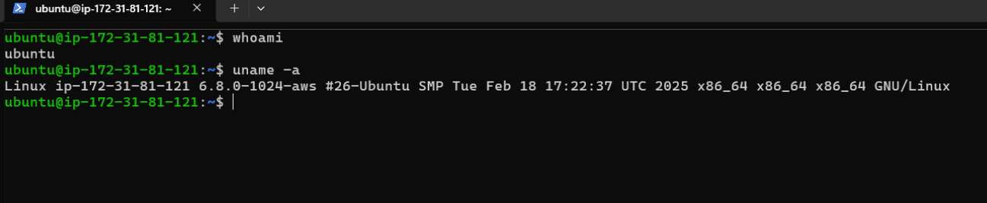

**2. Navigating to the Projects Directory**

Using **cd /projects**, I moved into the directory. I ran **ls -l** to list all files and folders with detailed info such as permissions, owner, and modification dates.

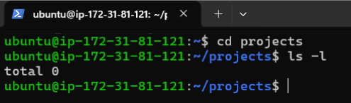

**3. Creating a New Project Directory**

I created a new folder named **projectB** using the **mkdir** command. After that, I used **ls -l** to confirm that the directory was created successfully and to check its default permissions and ownership.

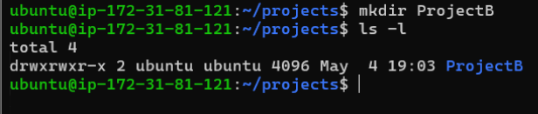

**4. Adding a Sample File**

I created a simple file called README.txt inside **projectB** using touch. Then I added a welcome message using echo, and finally displayed the file content with cat to verify it was written correctly.

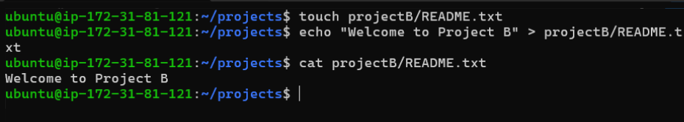

**Task 2: User and Group Permissions Management**

**1. Creating a New User and Group Assignment**

A new developer named John joined the team. I created his user account with **useradd -m -G developers john**, which also adds him to the developers group. I then set his password. Group assignment ensures he has the right level of access to shared resources.

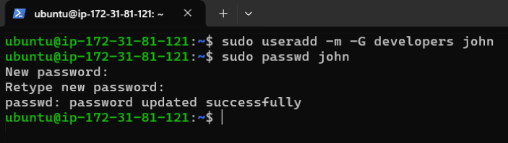

**2. Verifying User Details**

**id john** shows the UID, GID, and all the groups John belongs to. This helps confirm that he was added to the correct group.

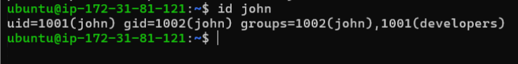

**3. Changing Group Ownership**

Since projectB is a shared project, I updated its group ownership to **developers** using **chown :developers**. This allows anyone in the group (like John) to collaborate on the project.

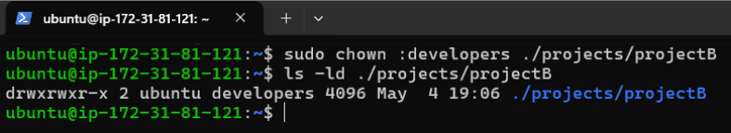

**4. Updating Permissions**

I set the permissions to **770 using chmod**. This means only the owner and members of the developers group can read, write, or access projectB.

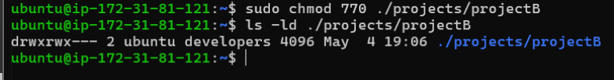

**Task 3: Changing File Ownership**

**1. Making John the Owner**

I changed ownership to John with **chown john:developers**. This gives him direct control over the directory and its contents.

**2. Verifying the Change**

I confirmed the ownership update using **ls -ld**. It now shows John as the owner and developers as the group, indicating that access rights are correctly set for both individual and team use. A screenshot of a computer

**Task 4: System-Level Monitoring Commands**

**1. Checking System Uptime**

Using the uptime command, I checked how long the system has been running, as well as the current load average.

**2. Monitoring Disk Usage**

The **df -h** command displays disk usage in a human-readable format.

**3. Checking Memory Usage**

I used **free -m** to view memory usage in megabytes. It shows how much RAM is in use, free, or available.

**4. Viewing Running Processes**

I ran **ps aux --sort=-%mem | head -5** to see the top processes by memory usage. This allows system admins to spot any resource-heavy services that might need attention or optimization.

